*Number and Operations in Base Ten – Rounding to the Nearest Ten (3NBT.1)*

GRADE

3rd

Action Based Learning/MATH



I will use *Math & Movement* Skip Counting Mats to understand rounding.

[](https://www.google.com/imgres?imgurl&imgrefurl=http://www.communityschoolnaples.org/page.cfm?p%3D1072&h=0&w=0&sz=1&tbnid=zs_ylVQYEnR7NM&tbnh=190&tbnw=265&zoom=1&docid=fFDgtVSo9oQ_yM&ei=KpZ_Uo_ABKL-4APB7oGYCQ&ved=0CAEQsCU)

MATERIALS

* *Math & Movement* 100's Number Grid
* Construction Paper with numbers 10, 20, 30, 40, 50, 60, 70, 80, 90, 100
* Pencils
* Smart Board lessons
* *Math & Movement* Round and Round activity sheet



* Have the Math & Movement 100’s Number Grid set up in the front of the classroom
* Set up the construction paper with numbers 10, 20, etc. on the right side of the mat corresponding with which number would be next on the 100’s grid row.
* Review the meaning of estimation. When you use what you know to make a reasonable guess about an amount.
* Can watch brainpopjr.com rounding and estimating
* Have students find a partner and each pair are to use the Math & Movement Pattern Graphic Organizer activity sheet to find patterns on the various mats around the room.
* You will have 8 minutes to complete your graphic organizer and then we will share our patterns.
* Examples of patterns:
  + Hop by 9’s: when you add the two digits of each large number together you get 9
  + Hop by 3’s: the large numbers are odd, then even, then odd, then event
  + Hop by 4’s: every large number is even
  + Add and Subtract mat: in each diagonal row, the tens and ones columns go up and down by one
  + Clock Hop: larger numbers end in either 5 or 0
  + Estimate how many books are on the book shelf. How many pencils are in the jar?
  + "When you estimate, you want to round to make the numbers easier to work with.

This means that you change the numbers so it ends in a 0.

* Have a student stand on the 13 on the 100's number grid mat.
* Ask the student which numbers that end in zero are on the ends of that row on the math (10, 20)
* "Is 13 closer to the 10 or the 20? (The student can jump and count from the 13 to the 10 and from the 13 to the 20.
* "When rounding, 13 is closer to the 10. So when you round 13 it would round to 10.
* Repeat the rounding for numbers 28, 36, and 45.
* "What pattern or magic number do you notice when rounding?
* If the number ends in 4 or less, you round to the lesser number with a 0, and if the number

ends in 5 or more, you round to the larger number ending in 0. If the number ends on 5, which is in

the middle. If you were given the choice of having more of something would you want it? So if you are on 5 you would round up to the larger number.

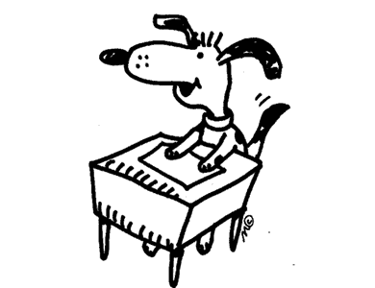

STUDENT WORK TIME

* Find a partner to work with and complete the Math & Movement Round and Round worksheet
* You will have 8 minutes to do this.